**Approach 4:**

After a lot of trials to make the model change “a w a y a w a y i f t h e y”

{ we still notice that the training is too fast for the model} we notices that the function load data does not load all the data set because of the If condition so by removing it “InD” length change from 9007 to 10500

When “InD” length was equal to 9007 it was Including a lot of empty cells after removing it its length become 318 (because of this we noticed the problem)

So, we have change the function load data to maximum amount of the data to be used in the model

We starts loading data by its path :

After this we have read the lines and start to separate the Speakers and the conversation by “:” then we took all conversation data and start splitting it into inputs{starts from index 0 and end at index i} and outputs {starts from index 1 and end at index i+1} and we have made a condition to check if there any empty cell to get ride of them before appending them to inputs and outputs and also before appending the conversation lines is passed to the function preprocess_sentence to get clean it and to get ride of any unnecessary symbols or space

After this we noticed that the length of “InD” and “OutD” increase and became more clean

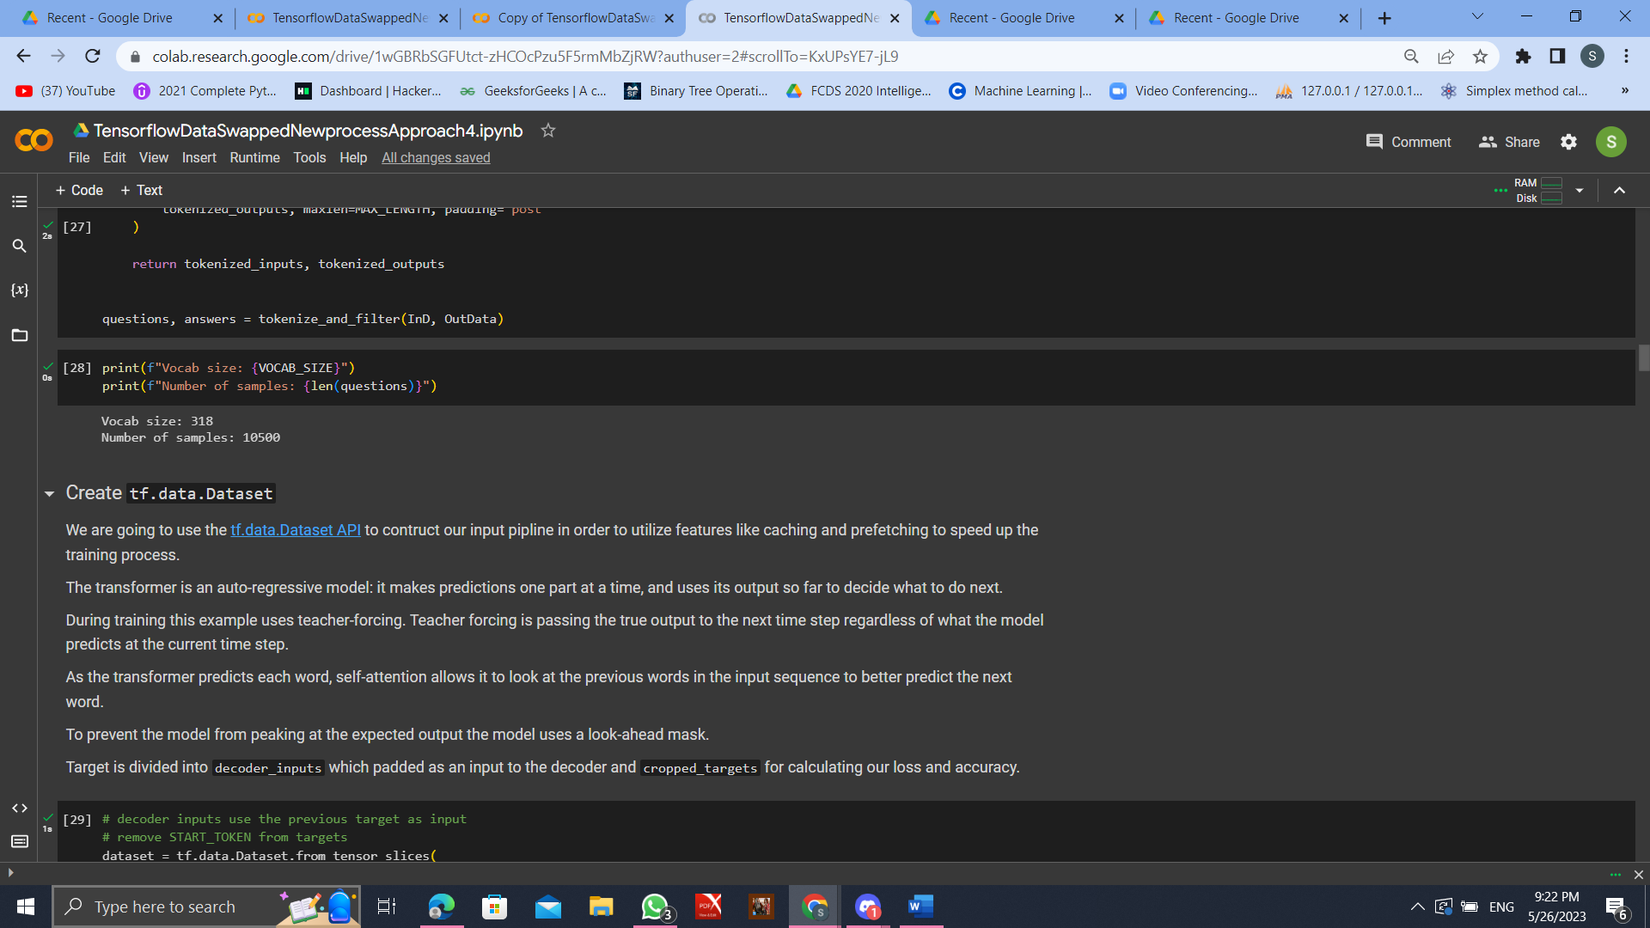And after using tokonizer we find that VOCAB_SIZE increased and of curse number of samples

So, After All these change we have to start training the model on the New Processed Data

Experiment#1:

* Optimizer AdamA
* Num_layer=2
* Epochs =50
* DropOut=0.1
* Num_heads=8
* Max_Lenght=316
* Max_Samples=10500

We noticed that we have to increase no_of_epochs and decrease dropout layer

Experiment#2:

* Optimizer AdamA
* Num_layer=2
* Epochs =250
* DropOut=0.0001
* Num_heads=8
* Max_Lenght=316
* Max_Samples=10500

